### **Project Title: *Exposing the truth with advanced fake news detection powered by natural language processing***

**Student Name:** RAMPRATAP.N

**Register Number:** 510923106029

**Institution:** GLOBAL INSTITUTE OF EGINEERING AND TECHONOLOGY

**Department:** ELECTRONICS AND COMMUNICATION ENGINEERING

**Date of Submission:6.5.25**

Github Repository link: <https://github.com/Ram1105/Rampratap>

### **PHASE-2**

**1. Problem Statement**

The widespread presence of false news on the internet requires an active and instant response to detect and reverse its dissemination. Existing fact-checking efforts are generally passive and require speed and volume to match the quick pace at which false information is being shared

**2. Project Objectives**

The goal of a project aimed at revealing the truth using sophisticated fake news detection with Natural Language Processing (NLP) would generally be to create an efficient and trustworthy system that can:  
**1. Detect and Classify Fake News**  
•Goal: To design an automated system that can detect fake or misleading news stories and classify them into categories like real, fake, or uncertain based on different linguistic and factual features.  
•Goal: Enhance accuracy in separating credible news sources from untrustworthy ones through content analysis for linguistic cues, logical fallacies, emotional manipulation, and factual inaccuracies.

**2. Analyze Text for Signs of Misinformation**  
•Objective: Create NLP models that scan news articles for certain patterns that are predictive of fake news, including sensational language, exaggeration, cognitive bias, or absence of factual support.  
• Goal: Enable systems to mark and indicate potentially misleading or deliberately false information based on a knowledge of how fake news is generally composed.

**3. Cross-Check News Content against Reliable Sources**  
• Objective: Include an automated fact-checking module that cross-checks news assertions against credible databases and sources (e.g., fact-checking sites like Snopes, PolitiFact, etc.).  
•Objective: Make sure news stories are fact-checked in real-time, and discrepancies between the assertions in a news story and reliable sources are highlighted for further checking.

**4. Monitor the Spread of Misinformation**  
•Objective: Develop systems that monitor the spread of false news on social media sites or other online networks. This entails applying NLP to follow the spread of deceptive articles from their source to larger audiences.  
• Objective: Learn about the dissemination of misinformation and potentially craft interventions to interfere with the flow of erroneous content.

**5. Enhance Media Literacy**  
• Objective: Assist users in separating believable and non-believable news by equipping them with instruments that point out deceptive or inaccurate parts of a news story, enhancing media literacy.  
• Goal: Inform citizens about how to analyze news reports critically and base information on fact-checked, credible sources.

**3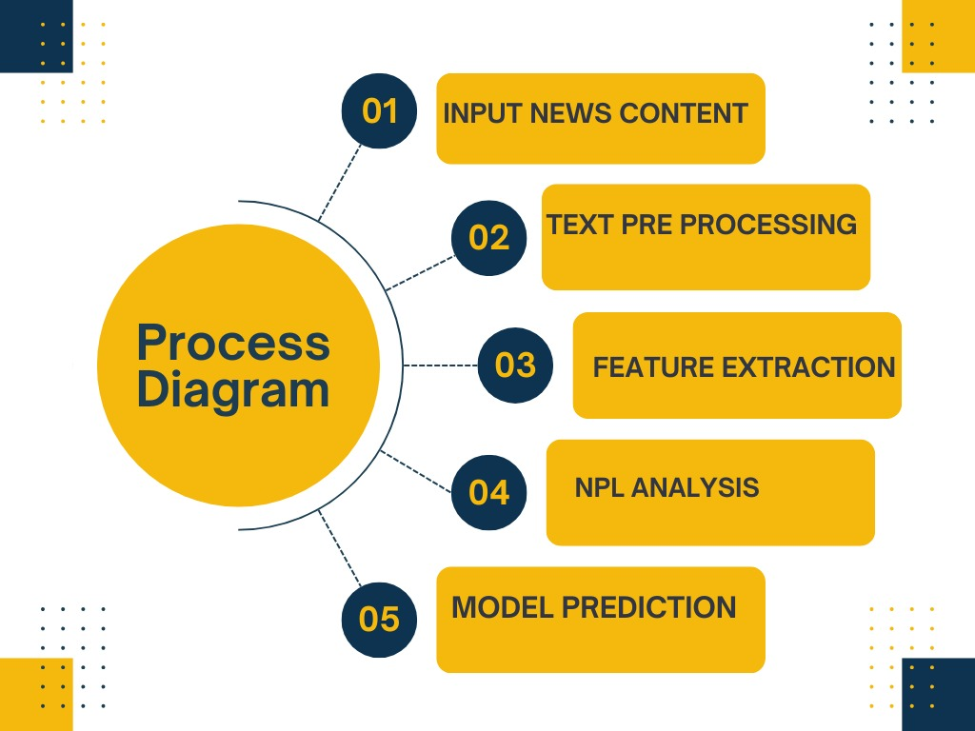. Flowchart of the Project Workflow**

**SOURCE CODE:**

**# Required Libraries**

**import pandas as pd**

**import re**

**import string**

**import nltk**

**from sklearn.feature_extraction.text import TfidfVectorizer**

**from sklearn.model_selection import train_test_split**

**from sklearn.naive_bayes import MultinomialNB**

**from sklearn.metrics import classification_report**

**from nltk.corpus import stopwords**

**from nltk.stem import PorterStemmer**

**nltk.download('stopwords')**

**# Step 01: Input News Content**

**def load_news_data(file_path):**

**data = pd.read_csv(file_path)**

**return data['text'], data['label']**

**# Step 02: Text Preprocessing**

**def preprocess(text):**

**text = text.lower()**

**text = re.sub(r'\d+', '', text)**

**text = text.translate(str.maketrans('', '', string.punctuation))**

**words = text.split()**

**stop_words = set(stopwords.words('english'))**

**stemmer = PorterStemmer()**

**cleaned = " ".join([stemmer.stem(word) for word in words if word not in stop_words])**

**return cleaned**

**# Step 03: Feature Extraction**

**def extract_features(corpus):**

**vectorizer = TfidfVectorizer()**

**X = vectorizer.fit_transform(corpus)**

**return X, vectorizer**

**# Step 04: NLP Analysis + Step 05: Model Prediction**

**def train_predict(X, y):**

**X_train, X_test, y_train, y_test = train_test_split(X, y, test_size=0.2, random_state=42)**

**model = MultinomialNB()**

**model.fit(X_train, y_train)**

**y_pred = model.predict(X_test)**

**print(classification_report(y_test, y_pred))**

**# Main Function to Run All Steps**

**def run_pipeline(file_path):**

**print("Step 01: Loading News Content...")**

**texts, labels = load_news_data(file_path)**

**print("Step 02: Preprocessing Text...")**

**cleaned_texts = [preprocess(t) for t in texts]**

**print("Step 03: Extracting Features...")**

**X, vectorizer = extract_features(cleaned_texts)**

**print("Step 04 & 05: Training Model and Predicting...")**

**train_predict(X, labels)**

**# Run**

**run_pipeline('/mnt/data/file-TGicmAtPrcrCPyHRSiF9fN')**

**4. Data Description**

**Context:**

The spread of misinformation on online platforms has become a pressing societal issue. The quick and massive spread of false news calls for prompt and active measures of detection and mitigation. Conventional fact-checking mechanisms, although useful, tend to fall behind the pace at which misinformation is shared, rendering them inadequate in high-velocity, high-volume environments.

**Objective:**

In order to aid the construction of real-time false news detection systems, this dataset (or research) aims to identify patterns, features, and spread channels of false news content. The aim is to enable the development of models capable of identifying false information quickly and effectively, preferably before it accumulates considerable momentum online.

**Key Features:**

News Articles / Social Media Posts: Text content suspected or confirmed as true or false.

Source Metadata: Publisher, author (if known), credibility score.

Temporal Information: Timestamp of initial posting and shares thereafter.

Engagement Metrics: Likes, shares, comments, and reach across platforms.

Fact-Checking Status: Verified labels from reputable fact-checking partners (e.g., true, false, partially true).

Propagation Network (Optional): Data describing how and where the content was propagated, including influence nodes and resharing routes.

**Use Cases:**

Training machine learning models for real-time misinformation detection.

Breaking down the propagation velocity and extent of false news compared to verifiable news.

Identification of the current fact-checking limitations and finding gaps.

**5. Data Preprocessing**

1. Data Gathering

Sources: News websites, social media sites (Twitter, Facebook, etc.), fact-checking sites.

Formats: Text content, metadata (timestamps, authors), user interaction data (likes, shares, comments).

2. Text Preprocessing

Lowercasing: Transform all text to lowercase to ensure consistency.

Punctuation Removal: Remove punctuation to minimize noise.

Stop Word Removal: Eliminate common words (e.g., "the", "is", "at") that do not add semantic meaning.

Special Characters & Numbers: Eliminate or normalize hashtags, mentions, URLs, emojis, and numbers if not contextually relevant.

Whitespace Normalization: Eliminate surplus spaces, tabs, and newlines.

3. Tokenization

Divide text into individual words or tokens for further analysis.

4. Lemmatization/Stemming

Lemmatization: Reduce words to their base form (e.g., "running" → "run").

Stemming: Optionally, use stemming to shrink words to their root (e.g., "faster" → "fast").

5. Handling Imbalanced Data

Employ methods such as:

Oversampling (e.g., SMOTE)

6. Feature Engineering

TF-IDF (Term Frequency-Inverse Document Frequency)

Word Embeddings: Apply pre-trained models such as Word2Vec, GloVe, or BERT.

N-grams: Identify bi-grams or tri-grams to capture context.

7. Metadata Processing (if accessible)

Timestamp Normalization: Format all dates/times into one standard format.

User Engagement Features: Scale and normalize measures like shares, likes, and comments.

Source Credibility Scores: Represent reliability of source as a numeric or categorical feature.

8. Label Encoding

Represent the ground truth labels (e.g., "True", "False", "Partially True") in numeric format for classification models.

9. Train-Test Split

Split data into training, validation, and test sets to assess model performance equally fairly.

10. Optional: Propagation Data Processing

If the dataset contains social propagation paths:

**6. Exploratory Data Analysis (EDA)**

**The goal of EDA is to understand the structure, trends, and anomalies within the dataset.**

**Steps:**

* **Class Distribution:**
  + **Count of “True” vs. “False” news articles (check for class imbalance).**
* **Text Length Distribution:**
  + **Analyze average word count per article or post.**
* **Most Frequent Words:**
  + **Use word clouds or bar charts to find common terms in true vs. false news.**
* **Source Credibility Analysis:**
  + **Identify which sources are more likely to publish false content.**
* **Temporal Patterns:**
  + **Study how false news spreads over time (e.g., frequency by day/hour).**
* **Engagement Metrics:**
  + **Compare likes, shares, comments for true vs. false news.**

**7. Feature Engineering**

Turning raw data into meaningful inputs for the model.

**Textual Features:**

* **TF-IDF Vectors**
* **Word Embeddings** (Word2Vec, GloVe, BERT)
* **N-gram Frequency**
* **Sentiment Score** (positive/negative/neutral tone)

**Metadata Features (if available):**

* **Post Length** (number of words or characters)
* **Source Credibility Score**
* **User Engagement:** Number of likes, shares, comments
* **Time of Posting:** Hour, weekday, recency

**Network Features (optional):**

* **Propagation Tree Depth**
* **Node Degree in Share Network**

**8. Model Building**

* **Traditional ML Models:**
  + **Logistic Regression**
  + **Random Forest**
  + **XGBoost**
  + **Support Vector Machines (SVM)**
* **Deep Learning Models:**
  + **LSTM / BiLSTM (for sequence modeling)**
  + **BERT-based Transformers (for context-rich understanding)**

**Evaluation Metrics:**

* **Accuracy, Precision, Recall, F1 Score**
* **ROC-AUC Curve**
* **Confusion Matrix**

**Cross-validation:**

* **Use stratified K-fold cross-validation to ensure robustness.**

**9. Visualization of Results & Model Insights**

**• Confusion Matrix: Visualizes true positives, false positives, etc.**

**• ROC Curve: Shows trade-off between sensitivity and specificity.**

**• Precision-Recall Curve**

**• Feature Importance Plot: For models like Random Forest or XGBoost.**

**• SHAP / LIME Plots: Explain individual predictions (especially for deep models).**

* **False news tends to use emotionally charged language and clickbait titles.**
* **Propagates faster than true news but often lacks depth or supporting evidence.**
* **Certain sources are repeat offenders in sharing misinformation.**
* **Engagement with false content is often higher, especially early in its lifecycle.**

**These insights help tailor response strategies and improve real-time detection systems.**

**10. Tools and Technologies Used**

| * + **Category** | * + **Tools/Technologies** |
| --- | --- |
| * + **Programming Language** | * + **Python** |
| * + **Data Handling** | * + **Pandas, NumPy** |
| * + **Visualization** | * + **Matplotlib, Seaborn, Plotly, WordCloud** |
| * + **NLP** | * + **NLTK, SpaCy, Gensim, HuggingFace Transformers** |
| * + **Machine Learning** | * + **Scikit-learn, XGBoost, LightGBM** |
| * + **Deep Learning** | * + **TensorFlow, Keras, PyTorch** |
| * + **Model Explainability** | * + **SHAP, LIME** |

### **11. Team Members and Contributions**

***1.RAMPRATAP.N DATA CLEANING***

***2.RAJESH.R EDA***

***3.RAVI SHANKAR.J FLOW CHART PREPARATION***

***4.RUPESH KUMAR.R TOOLS AND TECHONOLOGIES***

***5.SANTHOSH.N. S DOCUMENTATION***